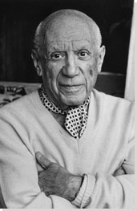
Artist Exploration 2: Pablo Picasso

Pablo Picasso was born October 25, 1881.He was born in Malaga, Spain. He was a Spanish painter, sculptor, printmaker, ceramicist, stage designer, poet and playwright who spent most of his adult life in France. He was part of the cubist movement. Pablo Picasso died on 8 April 1973 in Mougins, France from a heart attack and his wife was so devastated from his death that she killed herself by shooting herself in 1986 when she was 59 years old.

Interesting Facts:
- Picasso was born extremely small. In fact, he was so tiny that the nurse thought that he was stillborn. Therefore, she left him sitting on a table while she went to take care of his mother. His uncle wound up saving him from death.
- His father decided that he would give up painting when Picasso was 13 years old because he felt his son was already a better painter than him.
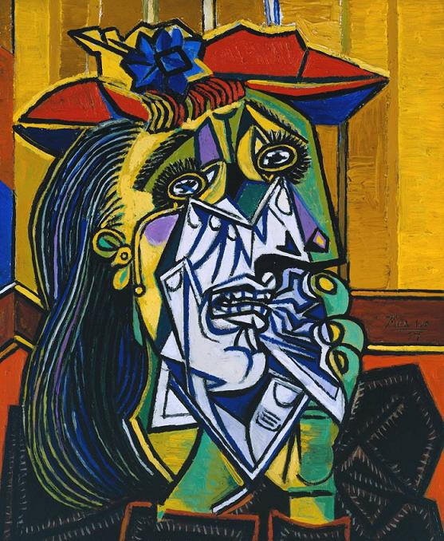
- The Nazis would not let Picasso display his paintings in Germany.

The work of art that I am critiquing is called: The Weeping Women
The artists name is: Pablo Picasso
What I see when I look at this art work is I see various shapes and colors and I see a women who is crying and is in pain. I see that the artist is trying to grab our attention using various colors and shapes to lure us in.
What are the two elements that stick out the most?
The two elements that stick out the most are the colors the artist used and the various shapes that he used in his paintings.

The mood for this artwork is?
The mood for this art work is sad, depressing, and painful. This painting is to be interpreting in a sad and depressing manor.
What is the message the author is trying to send?
The message the author is trying to communicate that sometimes life is sad and there are sometimes sad and depressing things that will happen in life. It is trying to say that not all of life’s stories are happy and that there can be sad moments to like losing somebody.
I like this artwork because it is very creative and it can speak to a public of many ages. It grabs the viewers’ attention and gives them something to think about. It also shows the reality of this world that sometimes there can be sad and depressing moments and not all of our lives is going to be happy. If I were a critique then I would give this work of art an 8.5/10.

