Artist Exploration and Analysis
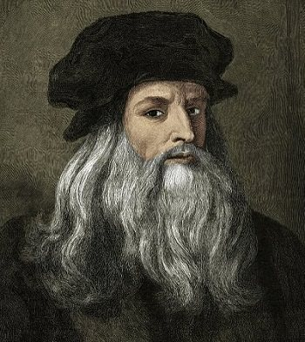
Leonardo Da Vinci is one of the most famous artists and is well known for his different type of art drawings. He was born in April 15, 1452 in a village known as Anchiano which is now known as Italy. He was known for his inventions, paintings, sculpting, architecture, science, music, math, engineering, literature, autonomy, geology, and many more things. His main focus was renaissance. He died at the age of 67 on May 2, 1519.He died of old age in the arms of the king. He was a very interesting man and had some very unique aspects and to this day he is well known and respected on a nationwide scale. The thing that makes this artist great is the diversity in his art and all of the types of art he did. I chose this artist because he is very inspiring to be a good artist and to try to live up to him and his art.

Interesting Facts:
- Leonardo Da Vinci was the first Italian to use oil paints
- Leonardo Da Vinci drew the plans for the first armored car in 1485
- Leonardo Da Vinci left many paintings unfinished and destroyed most of his work
Most Famous Paintings:
- The Last Supper
- Mona Lisa
- Vitruvian Man
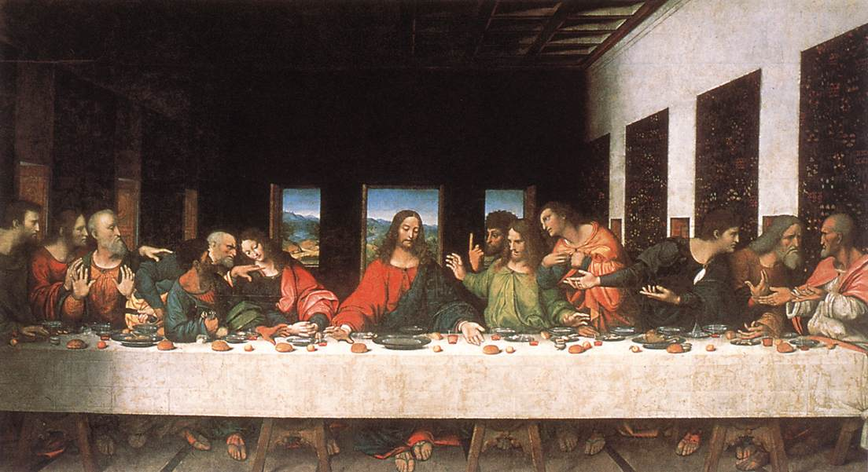

The work I am critiquing is called The Last Supper.
The artist name is Leonardo Da Vinci

What do you see when you look at this artwork?
When I look at the artwork I see that he puts a lot of time and effort into his work and he takes his time to make them exactly how he wants them to look. He wants his drawings to be very unique and he focuses on every single detail so that when the painting is put all together than it will look fantastic. I see Jesus telling his disciples of the bad news that is about to rain on him and I also see his disciples expression when they hear about it.
What are two elements that stand out in this painting?
The two elements that stand out the most are the colors and the space. The colors in the picture are not bright at all and this can mean that the artist was trying to draw out a sad scenario. Also the painting looks to have a lot of spacing in it. The table seems to take up a lot of space but still there is still more space in the back ground and this makes the painting look very spacey.
What message do you think the author was trying to express in this drawing?
I think the artist was trying to show one of the saddest parts of when Jesus was alive and he tried to tell us how shocked everybody was about the news that Jesus gave him. I think he was trying to express how hard and shocking it was for all of Jesus disciples to hear the news that Jesus was telling them
Overall though I really liked this painting because when I look at it I can feel exactly how the disciples felt about hearing the news and I can picture myself there at the time hearing Jesus say the bad news. I feel that the artist drew it exactly how he was supposed to and that he knew exactly how he wanted to draw it. I really liked all the elements that he put in his picture and I liked how he drew it. If I were an art critic I would give him a 10/10.

