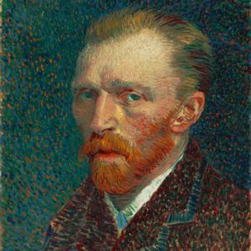
Vincent Van Gogh was a Dutch postimpressionist painter. He was born on March 30, 1853 at Zundert, Netherlands. He started painting in his twenties because as a child he was sick most of the time. Although he is a great artist, at the time while he lived no one paid attention to his art and critiques ignored his work until his death from suicide. He was a misunderstood artist. Since he was born in a rich family he got to travel a lot to London, Europe, and Paris. He died on July 29, 1890 in Auvers-sur-Oise, France at the age of 37.The cause of death was him shooting himself while committing suicide. I chose this artist because he is very talented although he is very misunderstood. He didn’t get the recognition that he wanted in till after his death and I think that his artwork is very amazing.
Interesting Facts
- Vincent van Gogh suffered from temporal lobe epilepsy, hallucinations and mental illness.
- During an epileptic seizure, Van Gogh attempted to attack his friend Paul Gauguin with an open razor. This ultimately resulted in the Vincent cutting off a piece of his own ear – not the whole ear.
- Vincent was a self-taught artist who learned on his own.
Top Famous Paintings
- Starry Night
- The Potato Eaters
- Irises
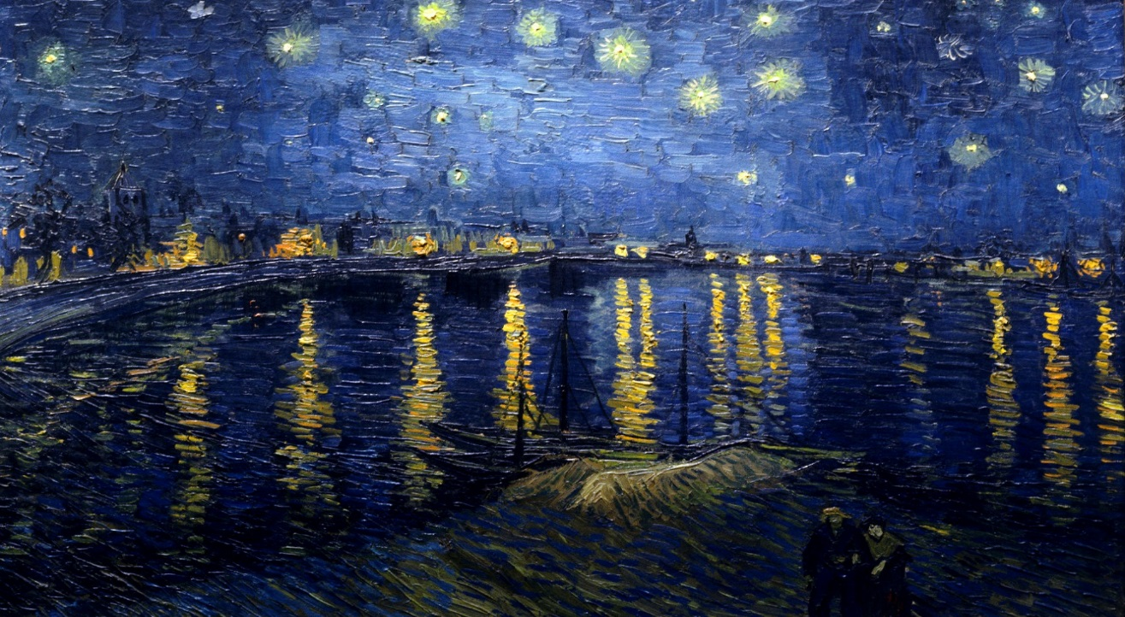

The work of art is called: Starry Night Over Rhone

The artist name is: Vincent Van Gogh
When I look at this art I see a bunch of stars over the sea or lake and there is a boat right under it. There are also two people walking away from the stars. I also see a lot of buildings with lights shining from them. It is also night.

What are the two elements that stand out the most in this art?
The two elements that stick out the most to me are the space and the color. The painting is drawn to look that it has a lot of space. It looks like it is very spacey. Also the color is so dark and no color is super right the colors make the painting look more realistic to real life.

What is the mood of the art?
The mood of the art is serious. The colors make it look very realistic and it looks so serious like if he was actually looking around and found that environment and he drew it exactly how he saw
It.

What is the message the artist is trying to send?
The message the artist is trying to send is the beauty of life and the beauty of how the world looks and of how beauty nature is. He is trying to tell us that there are more beautiful things that are worth seeing in real life.

I like this type of art because it actually captures the beauty of life. The colors he used made it look as if you were there actually looking at that scene in awe. If I were an art critique I would give him a 10/10. This artwork speaks out to me a lot.

